Sally Oketch.

[Sally.oketch@womentechsters.org](mailto:Sally.oketch@womentechsters.org)

PRACTICAL ACTIVITY 9

**Task 1**

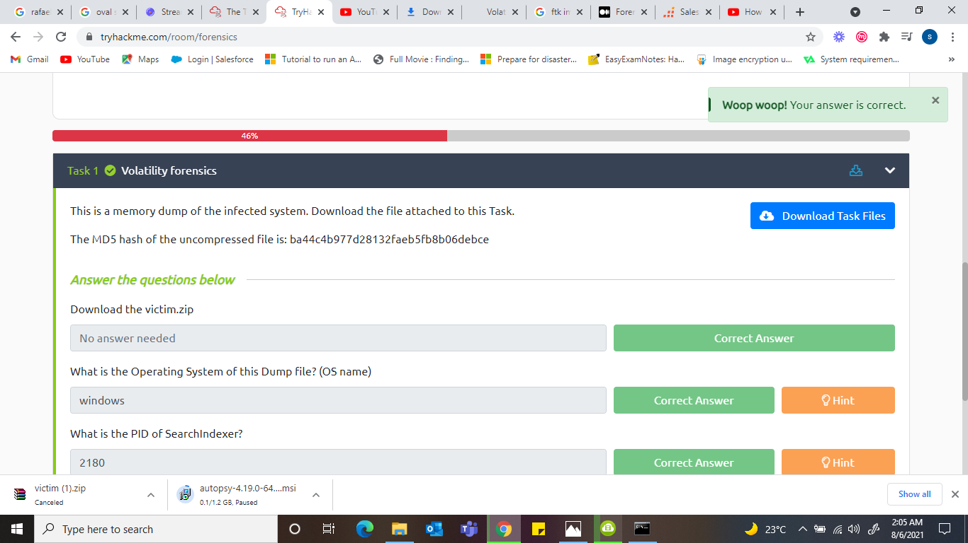

Operating system of dump file: ***windows***

***Volatility -f victim.raw imageinfo***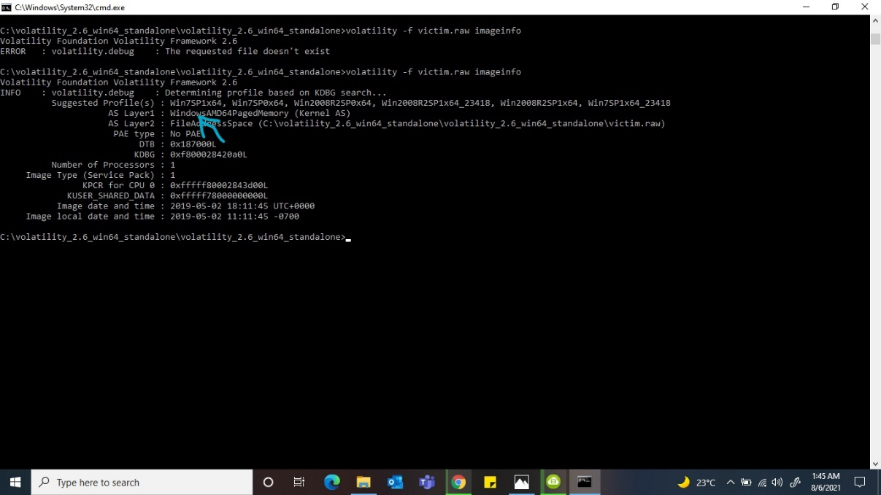

What is the PID of searchindexer***? 2180***

***Volatility -f victim.raw –profile=Win7SP1x64 pslist***

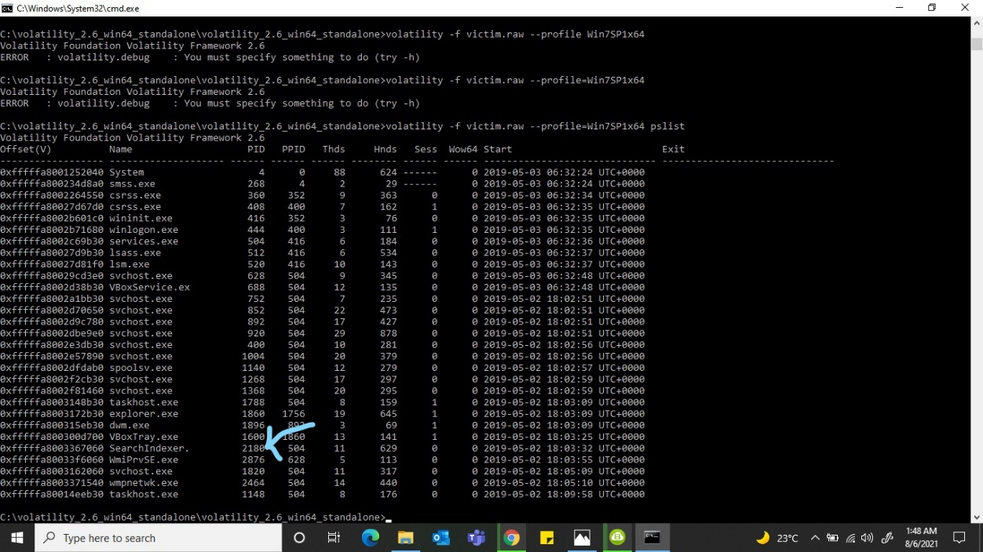

What is the last directory accessed by the user? deleted_files

***Volatility -f victim.raw –profile=Win7SP1x64 shellbags***

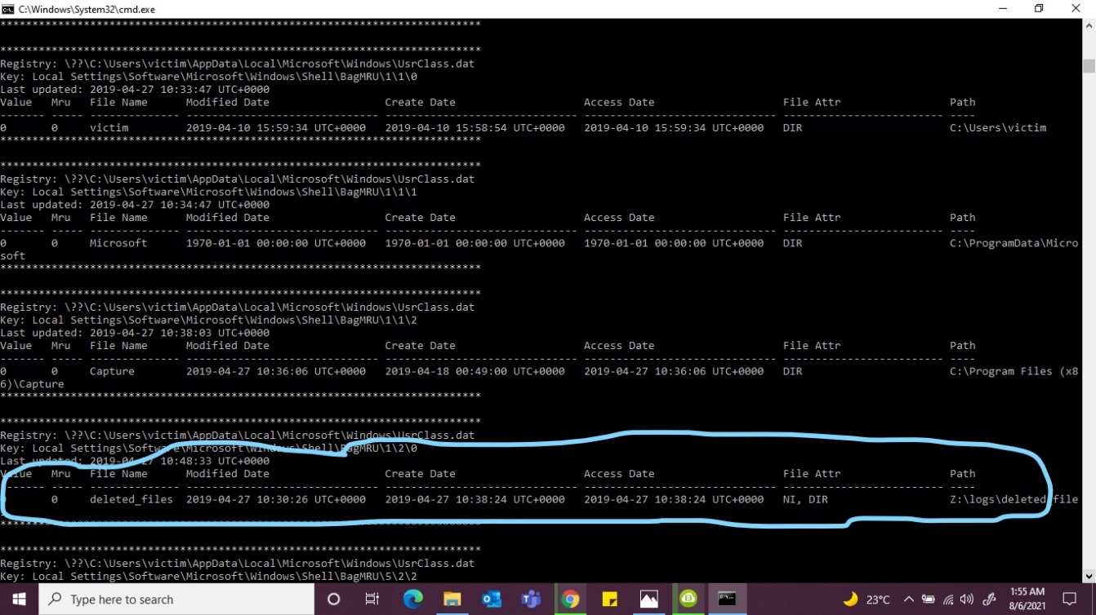

**Task 2**

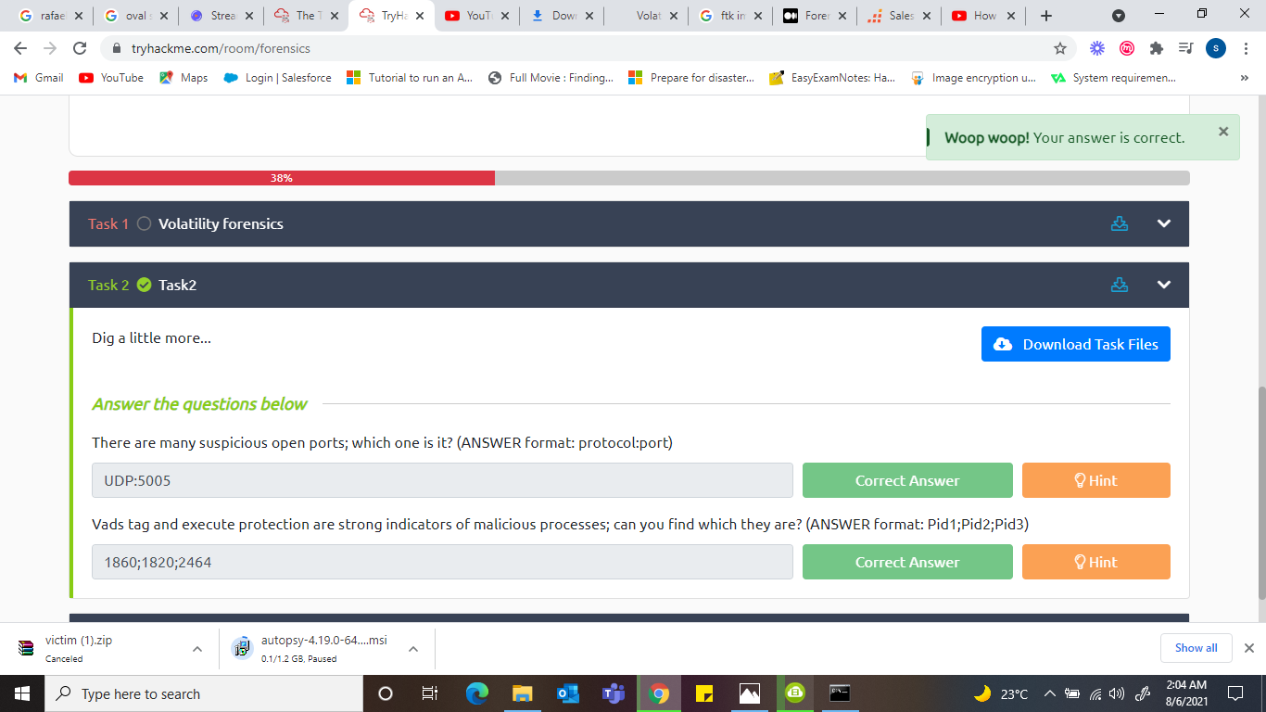

Suspicious open ports? ***UDP:5005***

***Volatility -f victim.raw –profile=Win7SP1x64 netscan***

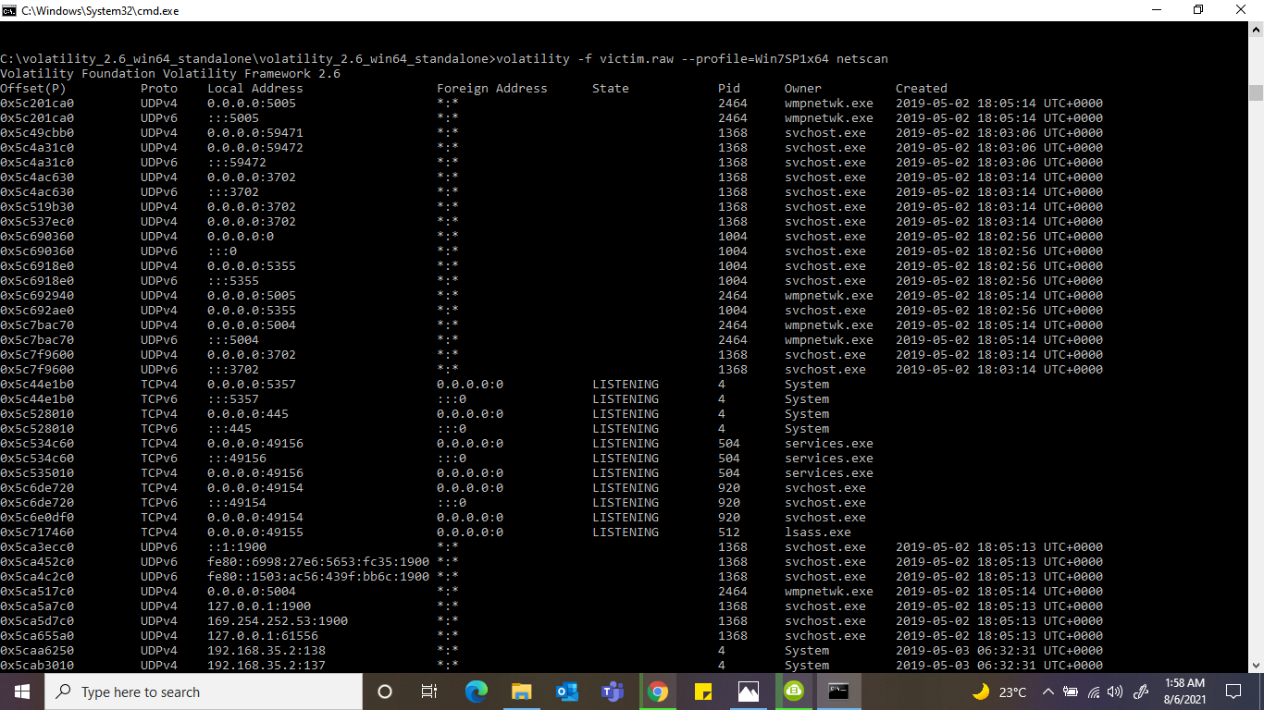

Vads tag and execute protection are strong indicators of malicious processes, which are they? ***1860;1820;2464***

***1860***

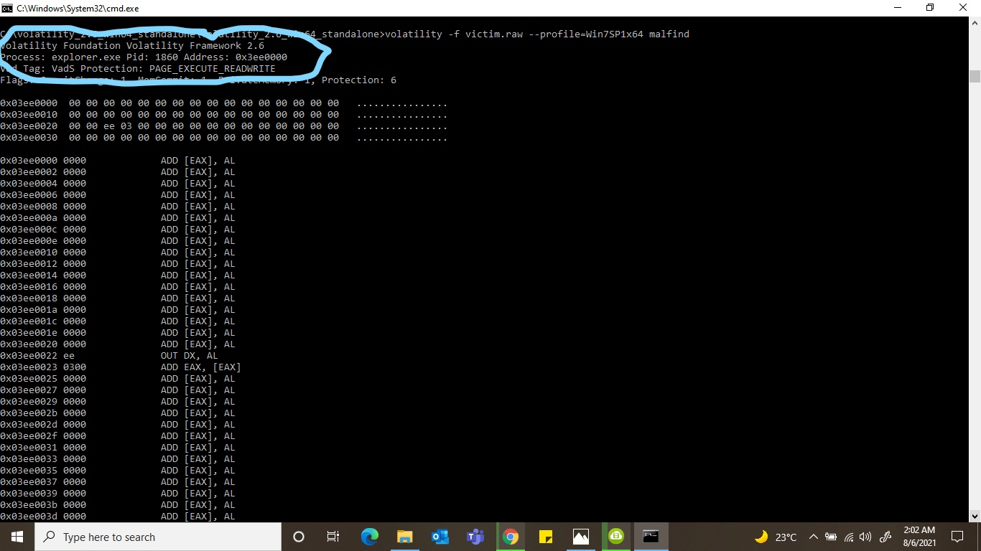

**2464**

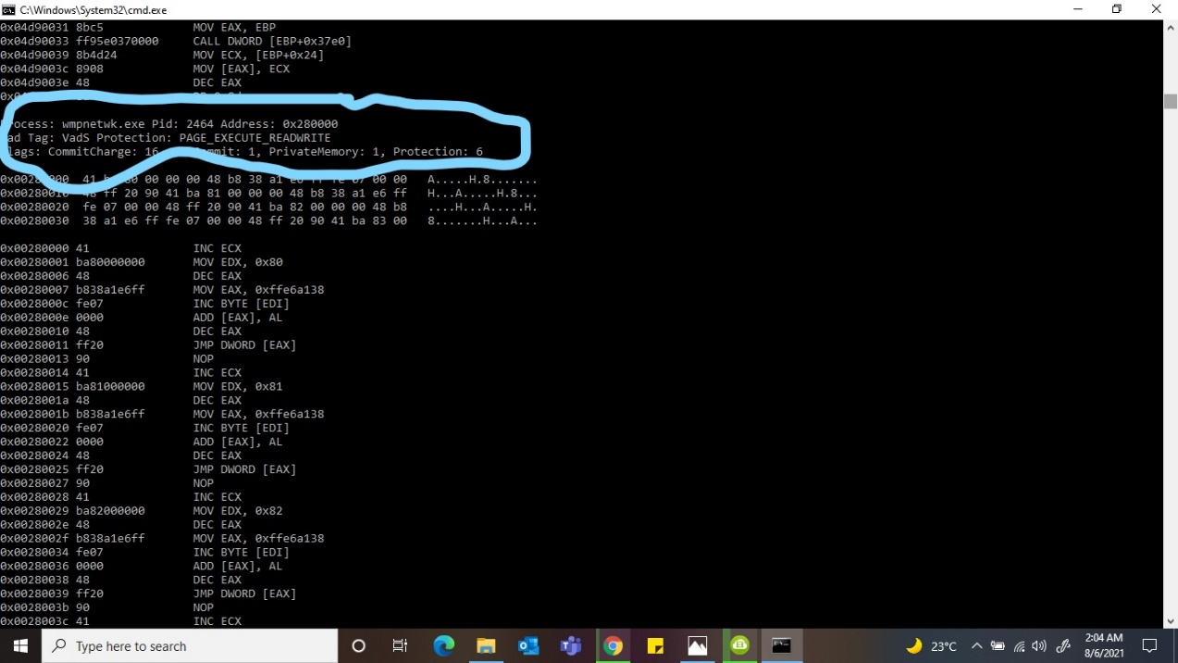

**1820**

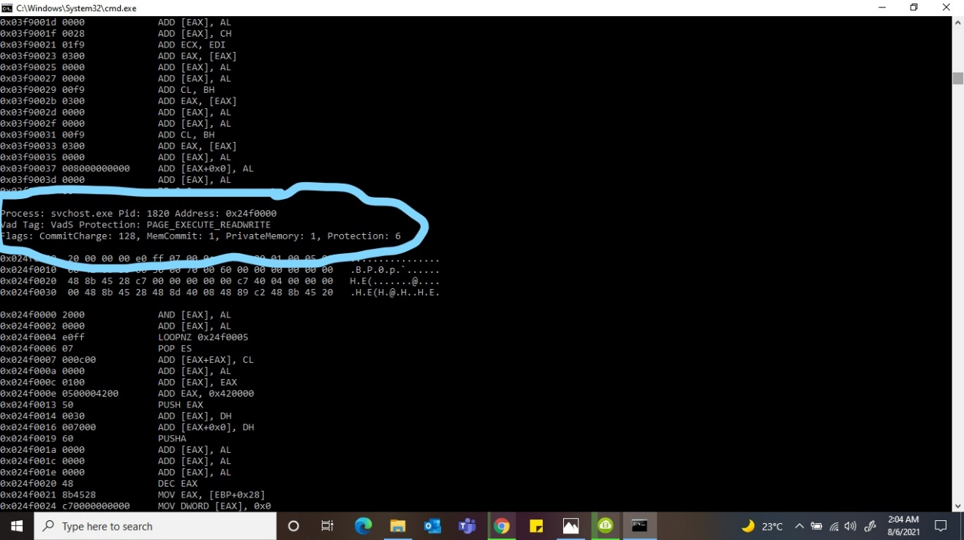

**TASK 3**

I went ahead and created 3 dump files using the memdump command.

**Volatility -f victim.raw –profile=Win7SP1x64 memdump -p 1860,1820,2464 -D**

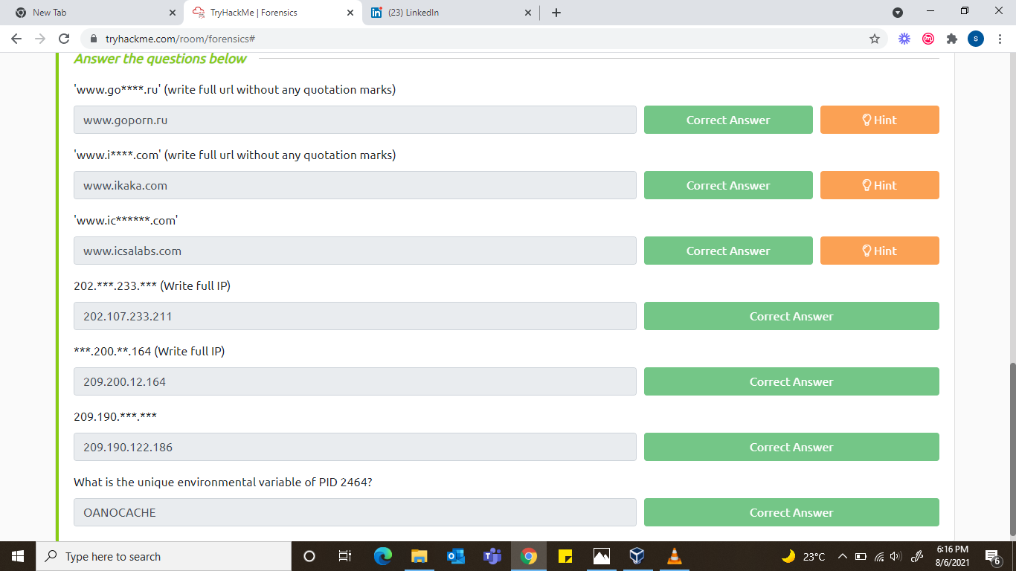

**‘www.go****.ru’**

**Strings 1820.dmp | grep ‘<\www\.go….\.ru\>’**

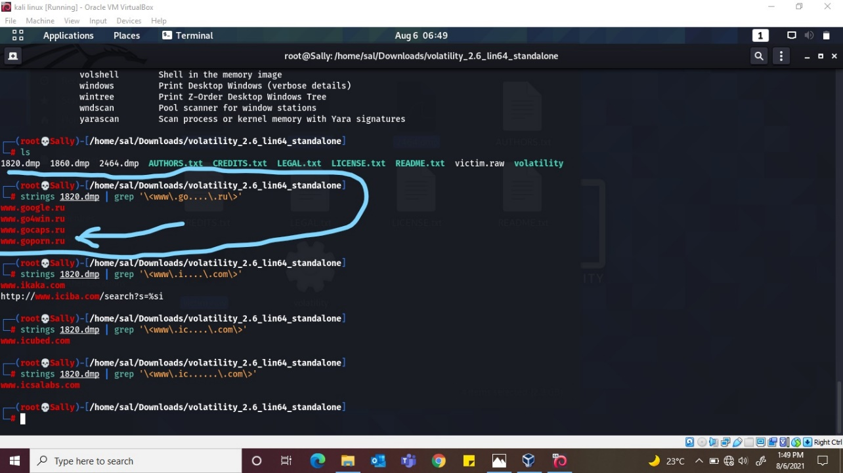

**‘www.i****.com’**

**Strings 1820.dmp | grep ‘<\www\.i….\.com\>’**

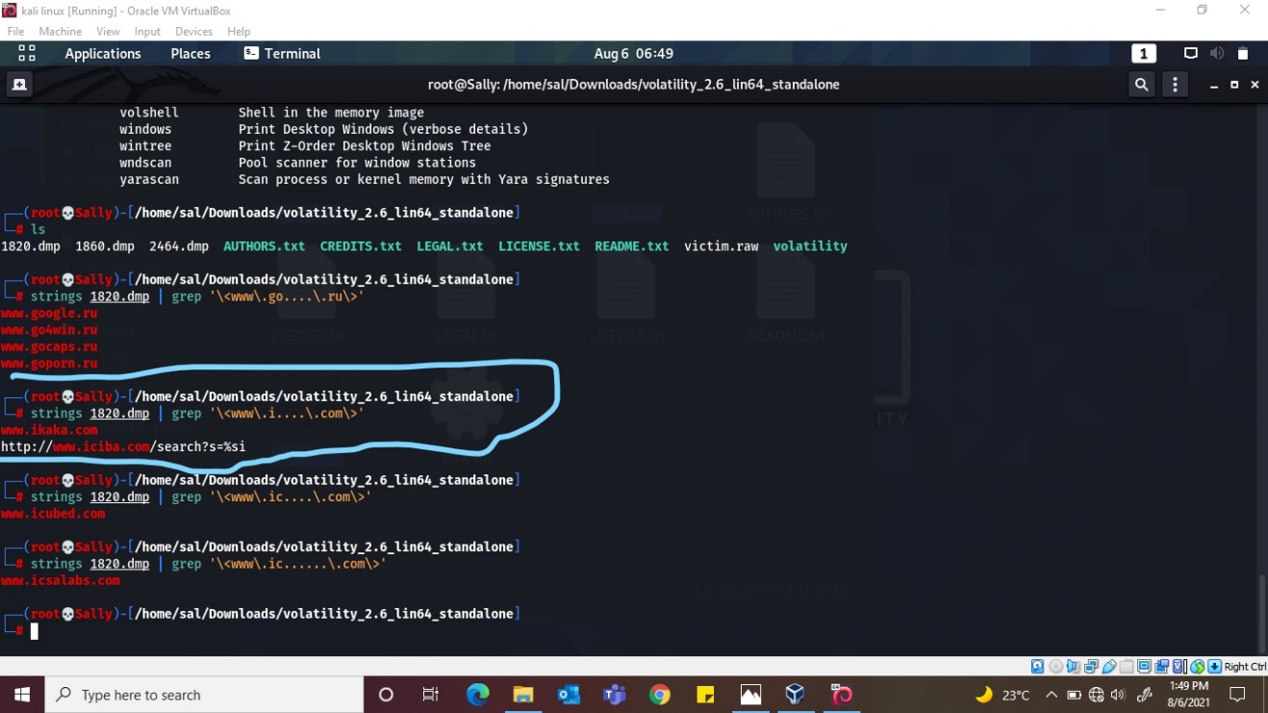

**‘www.ic******.com’**

**Strings 1820.dmp | grep ‘<\www\.ic..….\.com\>’**

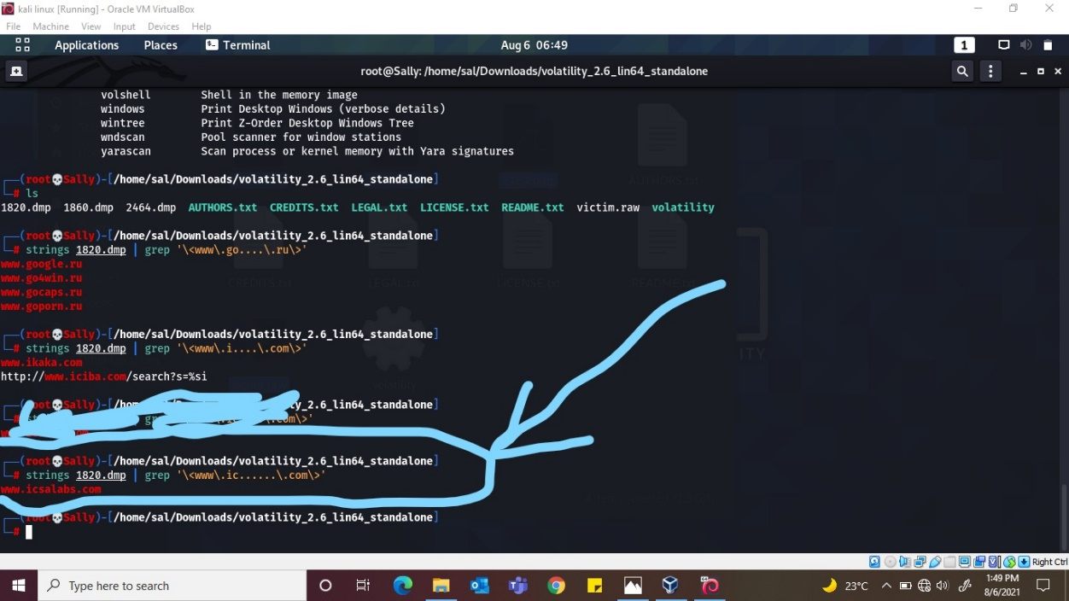

**202.***.233.\*\*\***

**Strings 1820.dmp | grep ‘\<202\...\.233\....\>’**

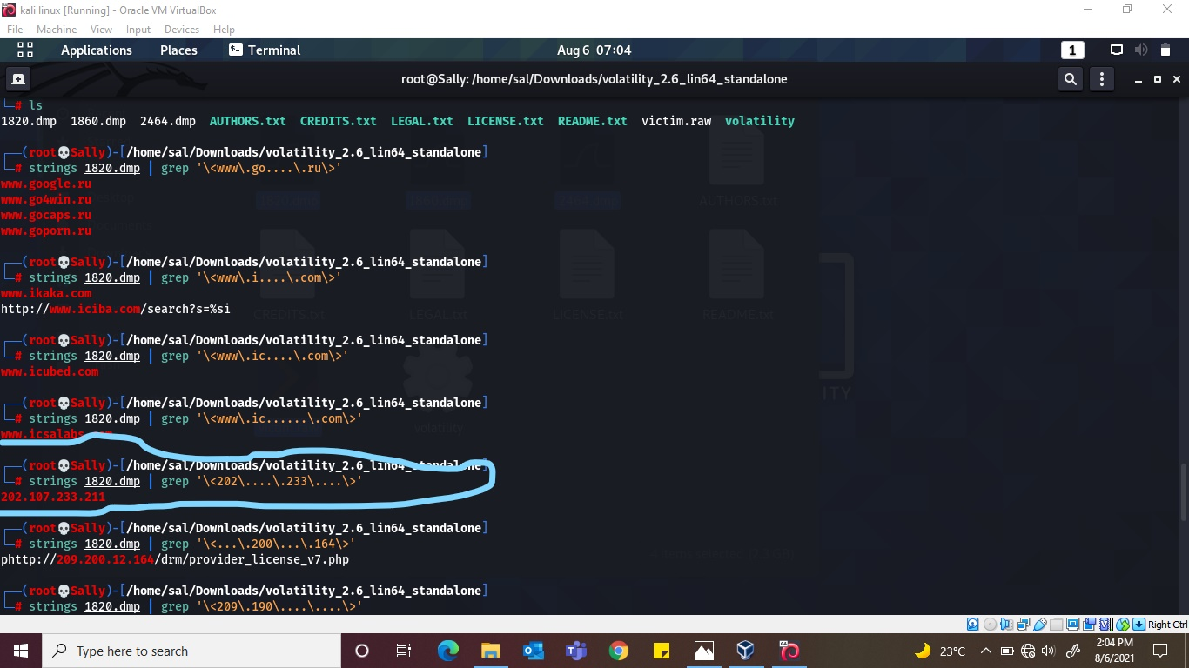

**\*\*\*.200.**.164**

**Strings 1820.dmp | grep ‘\<…\.200\...\.104\>’**

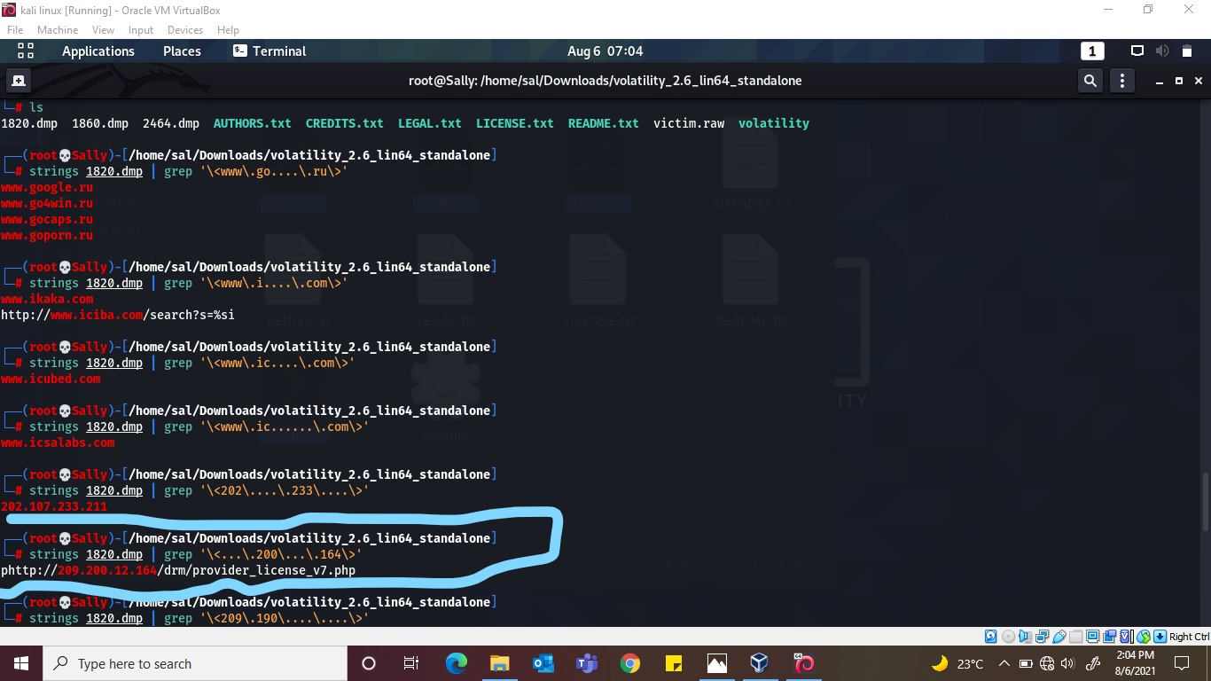

**209.190.***.\*\*\***

**Strings 1820.dmp | grep ‘\<209\.190\....\....\>’**

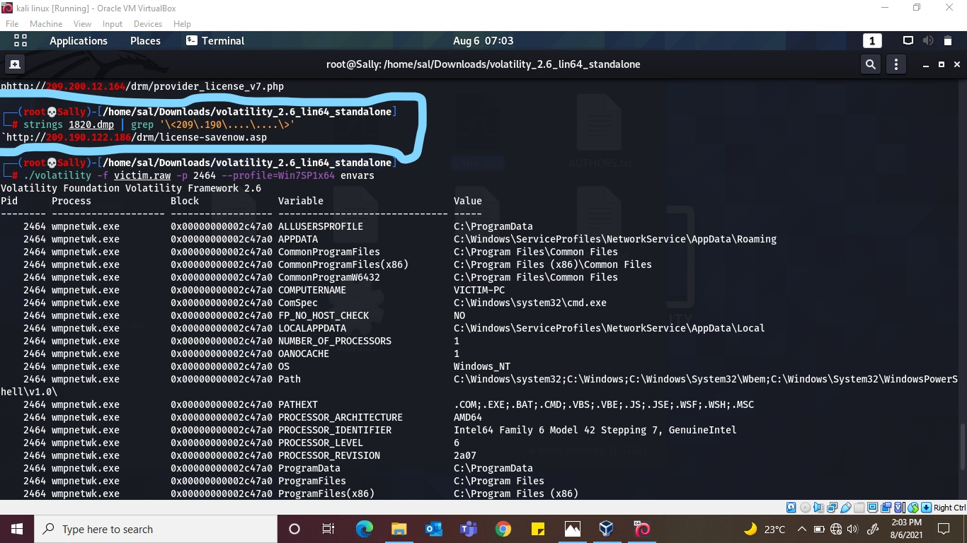

What is the unique environmental variable of PID 2464 ? **OANOCACHE**

**./volatility -f victim.raw -p 2464 –profile=Win7SP1x64 envars**

